
CSA15 – CLOUD COMPUTING AND BIG DATA ANALYTICS

ASSIGNMENT 1 – CO1

Design, Analyse and Validate a Virtualized Cloud Infrastructure for Efficient Resource Allocation and Data Centre Management.

CO1: Apply cloud computing technologies including hardware–software evolution, virtualization, web services, and service models to develop cloud-based solutions.

Field | Details | Field | Details
Student Name | S. MAGALAKSHMI | Register Number | 192524144
Department / Section | B.Tech AI&DS | Academic Year / Semester | 2nd year
Faculty Name | Dr.Arul Raj A.M | Nature of Assignment | Individual
Duration | 1 Week | Total Marks | 50
Submission Date | 5-11-2026 | Evaluation Date

MARK SHEET (Rubric-based evaluation)

Task | Title | Max | Awarded | Evidence / evaluation focus
1 | Existing Data Centre and Requirements | 3 |  | Definition; characteristics; deployment models; scenario mapping
2 | Virtualization Fundamentals and Hypervisors | 3 |  | Timeline; hardware evolution; relevance to university
3 | Server Consolidation and Resource Calculations | 3 |  | Web/software evolution; SOA; APIs; scenario relevance
4 | Virtual Machines and Containers | 5 |  | Hypervisor types; VM/container comparison; consolidation; limitations
5 | Virtualized Storage and Network Infrastructure | 4 |  | SOA and SOAP/REST; three university APIs; request/response examples
6 | Resource Allocation, Scheduling and Monitoring | 5 |  | Responsibility layers; five-application mapping; comparison; providers
7 | Availability, Security and Disaster Recovery | 3 |  | Four or more variants; two justified choices; provider risks
8 | Virtualized Cloud Data Centre Architecture | 5 |  | Labelled diagram; deployment/service models; scaling; security; DR
9 | Hands-on Implementation and Validation | 4 |  | Running VM/container; PaaS/SaaS; tests; actual screenshots
10 | Cost, Performance and Final Recommendation | 7 |  | Three-way comparison; 3-year costs; risks; phased roadmap
11 | Day-4 Design Challenge | 8 |  | Impact; evaluation; adaptation; evidence-based defence
 | TOTAL | 50 |  | Percentage :

EVIDENCE VERIFICATION CHECKLIST

Tasks | Evidence expected | Status (✓ / P / ✗) | Evaluator note
1–3 | Conceptual explanations, comparisons and relevant illustrations |  | Explanations and relevant scenario mapping documented
4 | Virtualization calculations with stated assumptions and peak-load caution |  | Calculations present; practical capacity validation recommended
5–7 | API examples, service responsibility table and justified XaaS choices |  | Required conceptual evidence documented
8 | Labelled architecture diagram, caption below figure and component justification |  | Architecture documented; sizing assumptions need testing
9 | Actual code, environment details, execution logs, API outputs and screenshots |  | Procedures provided; actual execution evidence not established
10 | Cost assumptions, 3-year totals, risk controls and migration roadmap |  | Estimates and rationale documented
11 | Day-4 changes, 10× load strategy, 99.9% target and 40-college isolation |  | Design analysis documented; practical validation pending

IMPLEMENTATION EVIDENCE CHAIN

Evidence item | Status | Observation
Source code |  | Flask REST API and Dockerfile provided in the proposed implementation
Virtualization |  | Docker container configuration documented; running-container evidence required
PaaS or SaaS |  | Managed web-service deployment procedure described; live deployment not verified
Functional test |  | Expected HTTP 200 response and JSON output documented; actual output required
Failure case |  | HTTP 404 test case documented; actual execution record required
Screenshots |  | Screenshot requirements identified; authentic screenshots need verification
Reproducibility |  | Build commands, run commands, endpoints and expected results specified

MANDATORY SUBMISSION EVIDENCE CHECK
✓ = Present in documented answer; P = Partly present; ✗ = Missing / not satisfied
Task | Evidence expected | Status | Evaluator note
1 | Cloud definition, characteristics, deployment models and scenario mapping |  | All conceptual requirements covered
2 | Evolution timeline, hardware development and university relevance |  | Well explained with relevant examples
3 | Internet software evolution, SOA and APIs |  | Clear explanation and scenario relevance
4 | Hypervisors, VM/container comparison and consolidation calculations |  | Calculations included; peak-load limitations discussed
5 | SOAP/REST comparison and three university APIs |  | API methods and request/response examples documented
6 | IaaS/PaaS/SaaS responsibility layers and application mapping |  | All five applications categorized with justification
7 | XaaS variants and two justified selections |  | Six variants explained; DBaaS and DRaaS recommended
8 | Labelled architecture, scaling, security and disaster recovery |  | Design and component justifications documented
9 | Working container, PaaS/SaaS deployment, actual tests and screenshots |  | Code and procedures provided; actual execution evidence requires verification
10 | Three-year cost comparison, risks and migration roadmap |  | Cost assumptions, calculations and recommendations included
11 | Impact analysis, 10× load, 99.9% availability and tenant isolation |  | Changed requirements evaluated; load-test evidence recommended

IMPLEMENTATION EVIDENCE CHAIN
Evidence item | Status | Observation
Source code |  | Python Flask REST API and Dockerfile documented
Virtualization |  | Docker build and run procedures provided; execution screenshot required
PaaS or SaaS |  | Cloud deployment steps described; actual deployment confirmation required
Functional test |  | HTTP 200 and expected JSON response documented; actual test output required
Failure case |  | HTTP 404 test case included; execution evidence required
Screenshots |  | Required screenshots identified but authenticity and completeness not verified
Reproducibility |  | Installation, configuration, commands and testing steps documented
Interpretation |  | Technical outcomes and implementation limitations explained
Code and report consistency |  | Proposed API, Docker configuration and testing procedure are aligned

SUBMISSION CHECKLIST (Not Separately Marked)
Requirement | Status
All 11 tasks answered | ☐ Yes ☐ Partly ☐ No
☐ Existing data-centre requirements and limitations are identified. | ☐Yes ☐ Partly ☐ No
☐ Virtualization and hypervisor types are explained. | ☐Yes ☐ Partly ☐ No
☐ Server consolidation calculations include working and assumptions. | ☐Yes ☐ Partly ☐ No
☐ VM and container comparison and workload mapping are included. | ☐Yes ☐ Partly ☐ No
☐ Storage and network virtualization are addressed. | ☐ Yes ☐Partly ☐ No
☐ Resource allocation and monitoring policies are included. | ☐Yes ☐ Partly ☐ No
☐ Security risks, backup and disaster recovery are discussed. | ☐Yes ☐ Partly ☐ No
☐ A labelled virtualized data-centre architecture diagram is included. | ☐ Yes ☐Partly ☐ No
☐ Implementation screenshots and actual test evidence are provided. | ☐ Yes ☐ Partly ☐ No
☐ Three-year cost analysis and migration roadmap are included. | ☐ Yes ☐ Partly ☐ No
GENERAL INSTRUCTIONS
• Use clear headings and answer each task in the order given.
• Include diagrams, tables, calculations and screenshots wherever requested.
• State assumptions and units for all numerical calculations.
• Use credible technical references and cite sources consistently.
• Ensure that implementation evidence reflects work actually performed by the team.
• Submit the report as a well-formatted document with a title page, contents, references and appendices where required.

OVERALL REMARKS

_______________  Student Signature | _______________  Faculty Signature | _______________  Program Director

CSA15 – Cloud Computing and Big Data Analytics
ASSIGNMENT 1
CO1: Apply cloud computing technologies including hardware–software evolution, virtualization, web services, and service models to develop cloud-based solutions.

Assignment Title:
Design, Analyse and Validate a Virtualized Cloud Infrastructure for Efficient Resource Allocation and Data Centre Management
(Total Marks – 50) Duration: 1 week
--------------------------------------------------------------------------------------------------------------
Scenario – University Data Centre Virtualization
A growing university operates an on-premises data centre that hosts its Student Information System, Learning Management System, Library Management System, Examination Portal, research applications and institutional website. Each major application runs on a separate physical server. Server resources are underutilized during normal periods, while admission, examination and result-publication periods create high demand. The university experiences rising electricity and maintenance costs, slow hardware procurement, limited scalability and inadequate disaster-recovery arrangements.
The current data-centre environment is assumed to have the following characteristics:
• 20 physical servers, each with 16 CPU cores, 64 GB RAM and 2 TB local storage.
• Average CPU utilisation is approximately 20%; peak utilisation reaches 90–95% during admission and examination periods.
• Most servers are dedicated to individual applications and cannot share unused capacity efficiently.
• There is no centralized virtual-machine (VM) management platform and no tested live-migration process.
• Backup is performed periodically, but a separate disaster-recovery site and documented recovery objectives are not available.
• The university wants to reduce infrastructure costs while improving availability, scalability, security and resource utilization.
You are appointed as a cloud infrastructure consultant. Analyse the existing environment and design a virtualized cloud data-centre solution. Your proposal must explain the role of hypervisors, virtual machines, containers, storage and networking virtualization, resource allocation, monitoring, security and disaster recovery. Justify all major decisions using calculations, diagrams and practical evidence.
Design Challenge:
On Day 4, the university announces that it will introduce a new digital learning platform and extend selected services to 10 affiliated colleges. The expected peak workload will increase to five times the current peak. The university requires at least 99.9% service availability, stronger tenant isolation and controlled operating costs. Re-evaluate your original design and decide whether it should be retained, modified or redesigned..
TASK 1 – Analyse the Existing Data Centre and Identify Requirements (3 Marks)
Study the current data-centre environment and identify the reasons for adopting virtualization.
Explain the purpose of a data centre and identify its major components: compute, storage, networking, power, cooling and management.
Identify at least four limitations of the existing physical-server environment.
Define resource utilization, server consolidation, scalability, availability and fault tolerance.
Prepare a requirement table covering performance, capacity, security, availability and cost.
Evidence Expected: A concise assessment of the existing environment, clearly linking each identified problem to a virtualization or cloud-infrastructure requirement.
TASK 2 – Explain Virtualization Fundamentals and Hypervisors (4 Marks)
Explain the technologies that enable multiple computing environments to share physical infrastructure.
Define virtualization and explain its purpose in a cloud data centre.
Explain the role and working of a hypervisor.
Differentiate Type-1 (bare-metal) and Type-2 (hosted) hypervisors with suitable examples such as VMware ESXi, Microsoft Hyper-V, KVM and Oracle VirtualBox.
Compare full virtualization, para-virtualization, hardware-assisted virtualization and OS-level virtualization (containers).
Recommend a suitable hypervisor for the university and justify the selection.
Evidence Expected: A labelled virtualization architecture diagram, comparison table and justified hypervisor recommendation.
TASK 3 – Design Server Consolidation and Calculate Resource Requirements (5 Marks)
Propose a consolidation plan to reduce the number of physical servers while maintaining sufficient capacity.
Explain physical-to-virtual (P2V) migration and server consolidation.
Estimate the total CPU and memory demand using the stated server specifications and average utilization. State all assumptions.
Assume a target average CPU utilization of 65% on the consolidated hosts. Calculate the minimum number of hosts required based on CPU capacity, then check whether memory capacity changes the result.
Include a reasonable capacity reserve for peak demand and host failure; show the calculation clearly.
Discuss resource overcommitment, CPU scheduling, memory ballooning and the noisy-neighbour problem.
Evidence Expected: Worked calculations showing CPU and memory requirements, assumptions, capacity reserve and the recommended number of physical hosts. A final number without working will not receive full credit.
TASK 4 – Compare Virtual Machines and Containers (4 Marks)
Determine which workloads should run in virtual machines and which can run in containers.
Explain the architecture and characteristics of virtual machines and containers.
Compare VM and container isolation, operating-system requirements, startup time, resource overhead, portability and management.
Map at least five university workloads (for example, database, legacy student system, web portal, learning platform and analytics service) to VMs or containers.
Explain how Docker and a container orchestration platform such as Kubernetes can support deployment and scaling.
Identify situations where a VM is more appropriate than a container.
Evidence Expected: A VM-versus-container comparison and a workload mapping table supported by technical justification.
TASK 5 – Design Virtualized Storage and Network Infrastructure (4 Marks)
Design storage and network resources that support the proposed virtualized data centre.
Explain storage virtualization and compare direct-attached storage (DAS), network-attached storage (NAS) and storage area networks (SAN).
Explain software-defined storage (SDS), thin provisioning, snapshots, replication and backup.
Explain network virtualization, virtual switches, VLANs, virtual networks and software-defined networking (SDN).
Propose separate logical network segments for administration, student services, databases and management traffic.
Recommend suitable storage and network approaches for performance, security and availability.
Evidence Expected: A labelled storage and network design with explanations of the selected technologies and their roles.
TASK 6 – Plan Resource Allocation, Scheduling and Monitoring (5 Marks)
Develop a resource-management strategy that allocates infrastructure capacity efficiently.
Explain CPU, memory, storage and network resource allocation to VMs and containers.
Compare static allocation and dynamic allocation, including resource reservations, limits and shares.
Explain load balancing, workload scheduling, auto-scaling and high availability.
Identify suitable performance indicators: CPU utilization, memory utilization, disk I/O, network throughput, latency and VM availability.
Propose monitoring and alerting methods, and explain how the administrator should respond to resource contention.
Evidence Expected: A resource-allocation policy table and a monitoring plan that includes measurable indicators, thresholds and corrective actions.
TASK 7 – Evaluate Data Centre Availability, Security and Disaster Recovery (4 Marks)
Identify the risks associated with a virtualized data centre and propose suitable controls.
Explain hypervisor security, VM isolation, secure VM images, patch management and privileged access control.
Discuss VM escape, VM-to-VM attacks, insecure snapshots, VM sprawl and denial-of-service risks.
Recommend network segmentation, encryption, multi-factor authentication, role-based access control and audit logging.
Explain backup, replication, snapshots, live migration and disaster recovery.
Define Recovery Time Objective (RTO) and Recovery Point Objective (RPO), and propose suitable targets for at least two university applications.
Evidence Expected: A risk-and-mitigation table and a disaster-recovery plan with justified RTO and RPO values.
TASK 8 – Create the Virtualized Cloud Data Centre Architecture (5 Marks)
Construct an end-to-end architecture integrating compute, storage, network, virtualization and management components.
Draw a labelled architecture showing users, internet or campus network, firewall, load balancer, physical hosts, hypervisor layer, VMs/containers, virtual network, storage and monitoring.
Show how the university applications are distributed across hosts and how shared resources are allocated.
Include a management plane for provisioning, monitoring, logging and policy enforcement.
Show backup or replication to a secondary site or cloud region.
Justify the architecture in terms of scalability, performance, fault tolerance, security and cost.
Evidence Expected: A complete, clearly labelled architecture diagram and a written justification for each major component and design decision.
TASK 9 – Hands-on Implementation and Validation (5 Marks)
Build a small proof-of-concept that demonstrates virtualization and resource management.
Create at least one VM using VirtualBox, VMware, Hyper-V or KVM, or create a container using Docker.
Deploy a simple university-related service, such as a web page, student-record API or database-backed application.
Configure CPU, memory and storage resources and record the selected values.
Perform functional tests and at least one resource or load test. Record the observations.
Capture screenshots of the VM/container configuration, running service, resource-monitoring output and test results.
Document installation steps, commands, configuration details, issues faced and how they were resolved.
Evidence Expected: Reproducible implementation steps, source/configuration files, annotated screenshots and actual test evidence. Do not present simulated results as actual execution.
TASK 10 – Evaluate Cost, Performance and Final Recommendation (3 Marks)
Evaluate the proposed solution against the existing physical data-centre arrangement.
Compare the current physical-server model and proposed virtualized model in terms of hardware cost, electricity, cooling, maintenance, licensing and administration effort.
Prepare a simple three-year cost comparison using clearly stated assumptions. Separate one-time capital expenditure from recurring operational expenditure.
Evaluate expected improvements in utilization, scalability, availability and manageability.
Identify risks such as licensing costs, vendor lock-in, skills requirements, hardware failure and migration downtime.
Provide a phased migration roadmap, identifying which applications should be migrated first and why.
Evidence Expected: A three-year cost table, risk analysis, migration roadmap and evidence-based final recommendation.
DAY-4 DESIGN CHALLENGE
TASK 11 – Re-evaluate and Adapt the Virtualized Infrastructure (8 Marks)
Changed Requirement
The university introduces a digital learning platform and extends selected services to 10 affiliated colleges. The expected peak workload increases to five times the current peak. The system must achieve 99.9% availability, provide secure isolation between colleges and remain within a limited operating budget.
Re-evaluate your original design. You may RETAIN, MODIFY or REDESIGN the proposed infrastructure.
Impact Analysis – 2 Marks
Identify changes in workload, users, storage, network traffic and availability requirements.
Explain how multi-tenant access affects VM/container isolation, network segmentation and access control.
Identify which original capacity and cost assumptions are no longer valid.
Capacity and Availability Evaluation – 2 Marks
Estimate the additional CPU, memory, storage and network capacity needed for the five-times peak workload.
Evaluate whether the proposed number of hosts and the existing failover arrangement are sufficient.
Explain the meaning of 99.9% availability (approximately 8.76 hours of downtime per year) and identify measures needed to approach it.
Adaptation or Redesign – 2 Marks
Decide whether to retain, modify or redesign the original infrastructure and justify the decision.
Describe the revised architecture. Consider clustering, live migration, auto-scaling, container orchestration, multi-zone deployment or hybrid-cloud capacity where appropriate.
Explain changes to resource-allocation policies, tenant isolation, backup and disaster recovery.
Evidence-Based Defence – 2 Marks
Support the revised design with capacity calculations and clearly stated assumptions.
Compare the cost and operational complexity of the original and revised designs.
Discuss trade-offs involving performance, availability, security, licensing and management effort.
Evidence Expected: A technically justified decision supported by revised architecture, capacity calculations, availability considerations, security controls and cost comparison.
.Re-evaluate your original design in response to these changed conditions. You may:
RETAIN → MODIFY → or REDESIGN
your original solution.
Impact Analysis – 2 Marks
Discuss:
- What has changed from the original problem
- Which original assumptions (load, users, availability, cost) are affected
- Why the web services and APIs now become critical
- How multi-tenant access by 40 colleges affects security and isolation
Evidence Expected: A clear analysis of how the changed requirements affect the original cloud design.
Evaluation of the Original Design – 2 Marks
Discuss:
- Whether the chosen service models and virtualization plan can handle a 10x load
- Whether auto-scaling and the single-region deployment are sufficient for 99.9% availability (about 8.76 hours of downtime allowed per year)
- Whether cost remains acceptable under the new load
- Whether another service model or XaaS offering would give better overall results
Evidence Expected: A technically supported evaluation of the original design under the new conditions.
Adaptation or Redesign – 2 Marks
Discuss:
- Decide whether to retain, modify or redesign the solution
- Describe the revised architecture (for example API gateway, container orchestration, serverless components, multi-zone deployment or a hybrid model)
- Explain what changed in the service model mix and in the virtualization approach
- If you retain the original design, give sufficient technical justification for why no change is required
Evidence Expected: An appropriate design response to the changed requirement, with clear technical reasoning.
Evidence-Based Defence – 2 Marks
Discuss:
- Capacity and availability calculations
- Cost comparison between the original and the revised design
- Security and multi-tenancy considerations
- Trade-offs such as vendor lock-in, complexity and migration effort
Evidence Expected: A well-supported final decision that follows logically from the analysis.
MARK DISTRIBUTION
Task | Title | Bloom's Level | Marks
Task 1 | Existing Data Centre and Requirements | L2 – Understand / Analyse | 3
Task 2 | Virtualization Fundamentals and Hypervisors | L2 – Understand | 3
Task 3 | Server Consolidation and Resource Calculations | L3 – Apply | 3
Task 4 | Virtual Machines and Containers | L4 – Analyse | 5
Task 5 | Virtualized Storage and Network Infrastructure | L3/L4 – Apply / Analyse | 4
Task 6 | Resource Allocation, Scheduling and Monitoring | L4 – Analyse | 5
Task 7 | Availability, Security and Disaster Recovery | L4 – Analyse | 3
Task 8 | Virtualized Cloud Data Centre Architecture | L6 – Create | 5
Task 9 | Hands-on Implementation and Validation | L3 – Apply | 4
Task 10 | Cost, Performance and Final Recommendation | L5 – Evaluate | 7
 | Subtotal

Task 11 | Day-4 Design Challenge | L4/L5/L6 – Analyse / Evaluate / Create | 8
 | TOTAL |  | 50

ANSWER

TASK 1 – Analyse the Existing Data Centre and Identify Requirements
1.1 Introduction
A data centre is a centralized facility that contains computing, storage, networking, power, cooling, and management infrastructure used to store, process, and deliver data and applications.
The university data centre supports important applications such as the Student Information System (SIS), Learning Management System (LMS), Library Management System, Examination Portal, research applications, and institutional website.
Currently, the university operates 20 individual physical servers. These servers experience low resource utilization during normal periods and high demand during admission, examinations, and result publication.
Virtualization is required to improve resource utilization, reduce infrastructure costs, increase scalability, and provide better availability.
1.2 Major Components of a Data Centre
Component | Purpose
Compute | Physical servers and processors execute applications and workloads.
Storage | Stores student records, examination data, research files, and application databases.
Networking | Connects servers, users, storage devices, and external networks.
Power | Provides reliable electrical power using UPS and backup generators.
Cooling | Maintains suitable temperature to prevent hardware overheating.
Management | Monitors, configures, allocates, and maintains infrastructure resources.
1.3 Limitations of the Existing Data Centre
Limitation | Explanation | Virtualization Requirement
Low resource utilization | Average CPU utilization is only 20%, leaving significant processing capacity unused. | Server consolidation
High operational cost | Maintaining 20 separate servers increases electricity, cooling, and maintenance expenses. | Shared infrastructure
Limited scalability | Adding physical servers requires procurement, installation, and configuration. | Dynamic resource allocation
Poor availability | Failure of a dedicated physical server can interrupt its application. | High availability and failover
Peak-load problems | CPU utilization reaches 90–95% during admission and examinations. | Load balancing and resource scheduling
Inadequate disaster recovery | Periodic backups exist, but no tested disaster-recovery site is available. | Replication and disaster recovery
Lack of centralized management | There is no centralized VM management platform or tested live migration. | Centralized virtualization management
1.4 Important Definitions
Term | Definition
Resource Utilization | The percentage of available CPU, memory, storage, or network capacity being used.
Server Consolidation | Combining workloads from multiple physical servers onto fewer physical servers using virtualization.
Scalability | The ability of infrastructure to increase or decrease resources according to workload demand.
Availability | The percentage of time a system remains operational and accessible.
Fault Tolerance | The ability of a system to continue operating even when a component fails.
1.5 Requirement Analysis Table
Requirement | Identified Need | Proposed Solution
Performance | Handle peak admission and examination workloads. | CPU scheduling, load balancing, and resource reservations.
Capacity | Support 20 existing servers and future applications. | Server consolidation with sufficient CPU and memory reserves.
Security | Protect student records and examination information. | Network segmentation, RBAC, MFA, and encryption.
Availability | Maintain access to SIS, LMS, and examination services. | High-availability clusters and automated failover.
Cost | Reduce electricity, cooling, and hardware maintenance expenses. | Virtualization and shared infrastructure.
1.6 Conclusion
The existing university data centre suffers from low resource utilization, high operating costs, limited scalability, and inadequate disaster recovery. Implementing virtualization will allow multiple virtual machines to share physical resources efficiently.
Therefore, a virtualized cloud infrastructure with centralized management, resource scheduling, high availability, and disaster recovery is recommended to improve the university's data-centre performance and efficiency.

ASK 2 – Explain Virtualization Fundamentals and Hypervisors
2.1 Definition of Virtualization
Virtualization is a technology that creates multiple virtual computing environments on a single physical computer or server. It allows physical resources such as CPU, memory, storage, and networking to be shared among multiple virtual machines.
Each virtual machine operates independently and can run its own operating system and applications.
In the university data centre, virtualization allows multiple applications such as the Student Information System, Learning Management System, Library Management System, and Examination Portal to run on fewer physical servers.
Purpose of Virtualization in a Cloud Data Centre
- Improve utilization of physical resources.
- Reduce the number of physical servers.
- Reduce electricity, cooling, and maintenance costs.
- Enable rapid provisioning of virtual machines.
- Support workload migration and dynamic resource allocation.
- Improve availability through VM replication and failover.
2.2 Role and Working of a Hypervisor
A hypervisor is software or firmware that creates, runs, and manages virtual machines by allocating physical hardware resources to them.
It acts as an intermediate layer between the physical hardware and virtual machines.
Working of a Hypervisor
- The hypervisor is installed on or above the physical hardware.
- It creates virtual machines with virtual CPU, memory, storage, and network interfaces.
- Each VM runs its own operating system and applications.
- The hypervisor schedules CPU time and allocates memory to each VM.
- It isolates the VMs so that the failure of one VM does not normally affect other VMs.
- It supports VM management, resource allocation, and migration.
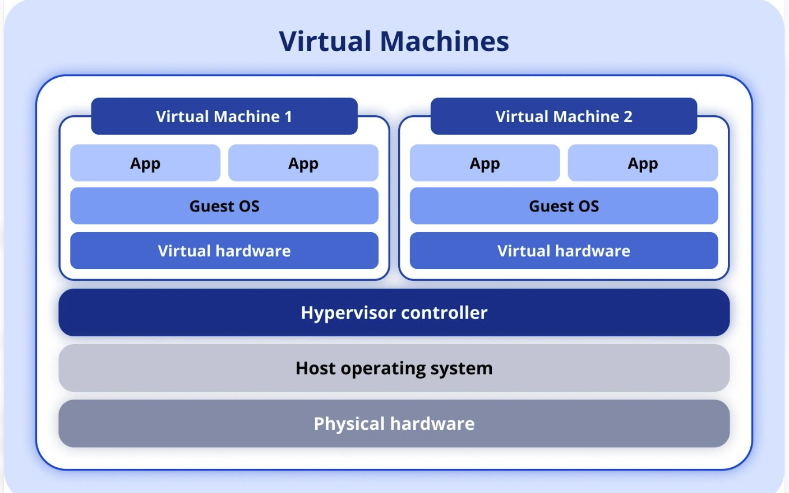
2.3 Types of Hypervisors
Type-1 Hypervisor (Bare-Metal)
A Type-1 hypervisor runs directly on the physical hardware without requiring a conventional host operating system.
Characteristics:
- High performance and efficient resource management.
- Suitable for enterprise and cloud data centres.
- Provides strong VM isolation.
- Supports centralized management and high availability.
Examples:
- VMware ESXi
- Microsoft Hyper-V
- KVM
Type-2 Hypervisor (Hosted)
A Type-2 hypervisor runs as an application on top of an existing host operating system such as Windows or Linux.
Characteristics:
- Easy to install and configure.
- Suitable for learning, development, and testing.
- Depends on the host operating system.
- May have additional performance overhead.
Example:
- Oracle VirtualBox

Comparison of Type-1 and Type-2 Hypervisors
Feature | Type-1 Hypervisor | Type-2 Hypervisor
Installation | Directly on hardware | On a host OS
Performance | Generally higher | Additional host OS overhead
Security | Smaller host OS dependency | Depends on host OS security
Resource management | Direct hardware management | Through host OS
Usage | Enterprise data centres | Desktop testing and development
Examples | ESXi, Hyper-V, KVM | VirtualBox, VMware Workstation

2.4 Comparison of Virtualization Technologies
Technology | Explanation | Example
Full Virtualization | Provides a complete virtual hardware environment for an unmodified guest OS. | VMware ESXi
Para-Virtualization | The guest OS is modified or uses special interfaces to cooperate with the hypervisor. | Xen PV
Hardware-Assisted Virtualization | Uses processor features such as Intel VT-x or AMD-V to improve virtualization. | KVM with VT-x/AMD-V
OS-Level Virtualization | Multiple isolated environments share the same host OS kernel. | Docker containers
Explanation
Full virtualization: The guest operating system behaves as if it is running on a physical computer. The hypervisor provides virtual hardware.
Para-virtualization: The guest operating system is aware of virtualization and communicates with the hypervisor using special interfaces, which can reduce overhead.
Hardware-assisted virtualization: Modern processors provide virtualization support that enables efficient execution of virtual machines.
OS-level virtualization: Containers share the host operating system kernel while maintaining separate application environments. It is lightweight compared with a complete VM.
2.5 Recommended Hypervisor for the University
The university should adopt a Type-1 hypervisor such as VMware ESXi or KVM for its virtualized data centre.
For this assignment, KVM is recommended because it is an open-source virtualization technology integrated with the Linux kernel.

Justification
- Cost-effectiveness: KVM avoids mandatory hypervisor licensing costs, although management, support, and other software may still incur costs.
- Performance: It supports hardware-assisted virtualization and efficient CPU and memory management.
- Scalability: It can host multiple VMs on consolidated physical servers.
- Security: It provides VM isolation and supports integration with Linux security mechanisms.
- Flexibility: It supports different guest operating systems and can be managed using tools such as libvirt.
- Cloud integration: It can be integrated with cloud management platforms such as OpenStack.
KVM is suitable for the university because it provides an economical and flexible foundation for server consolidation and future cloud expansion.
2.6 Conclusion
Virtualization enables the university to share physical resources efficiently while maintaining independent virtual environments for different applications. A hypervisor manages resource allocation and VM isolation.
A Type-1 hypervisor such as KVM is recommended because it provides efficient resource management, scalability, and cost-effectiveness for an enterprise data centre.

TASK 3 – Design Server Consolidation and Calculate Resource Requirements
3.1 Introduction
Server consolidation is the process of combining workloads from multiple physical servers onto a smaller number of physical servers using virtualization.
Physical-to-Virtual (P2V) migration converts an existing physical server into a virtual machine. The operating system, applications, and data are transferred to a virtualized environment.
The university currently uses 20 physical servers. Since average CPU utilization is only 20%, much of the available processing capacity remains unused.
By implementing virtualization, multiple university applications can share physical resources, reducing hardware requirements and operational costs.
3.2 Given Data and Assumptions
Parameter | Value
Existing physical servers | 20
CPU cores per server | 16
RAM per server | 64 GB
Storage per server | 2 TB
Average CPU utilization | 20%
Peak CPU utilization | 90–95%
Target average CPU utilization | 65%
Calculation assumptions:
- The proposed physical hosts have the same specifications as the existing servers: 16 CPU cores and 64 GB RAM.
- CPU utilization is calculated using the total available physical CPU cores.
- Memory utilization is not provided in the question. For sizing, assume 60% average memory utilization.
- A 20% capacity reserve is maintained for operational flexibility.
- N+1 redundancy is used, meaning the cluster must continue operating after one physical host fails.
- The CPU target of 65% is an average utilization target, not a guarantee that peak utilization will remain below 65%.

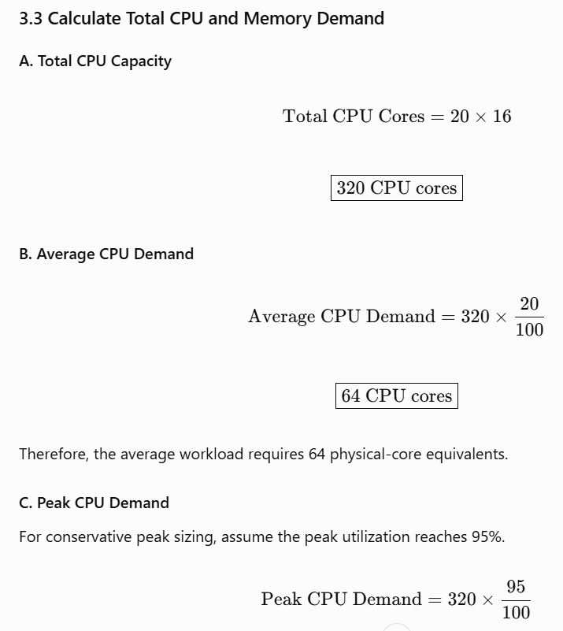

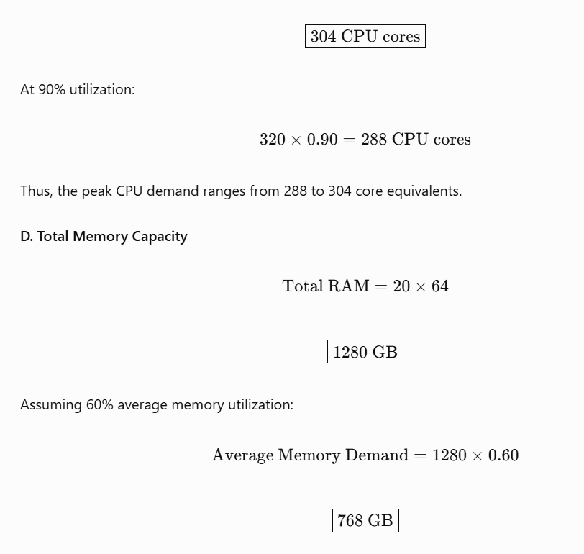
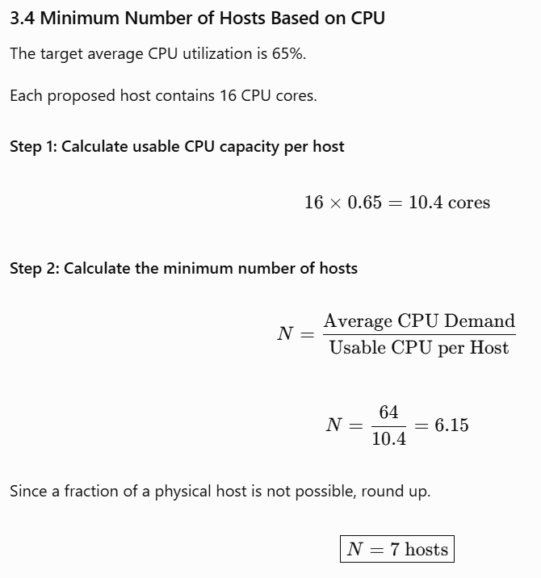

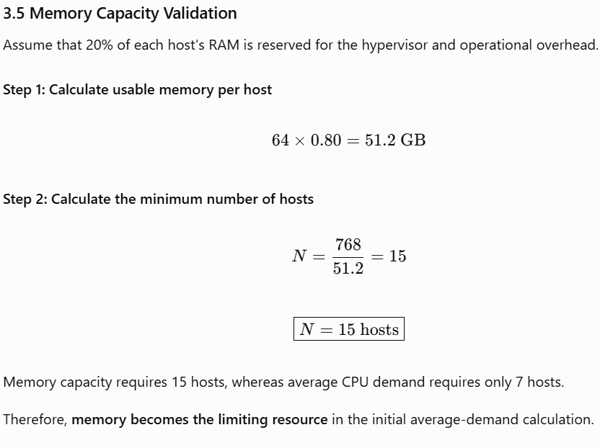

3.6 Capacity Reserve and N+1 Host-Failure Calculation
The university experiences high CPU utilization during admission, examinations, and result publication. Therefore, the average-demand calculation alone is not sufficient for final sizing.

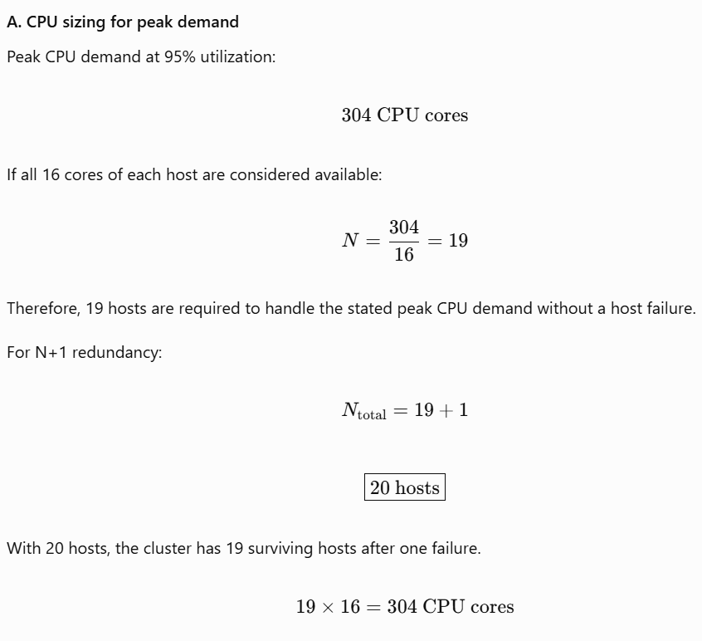

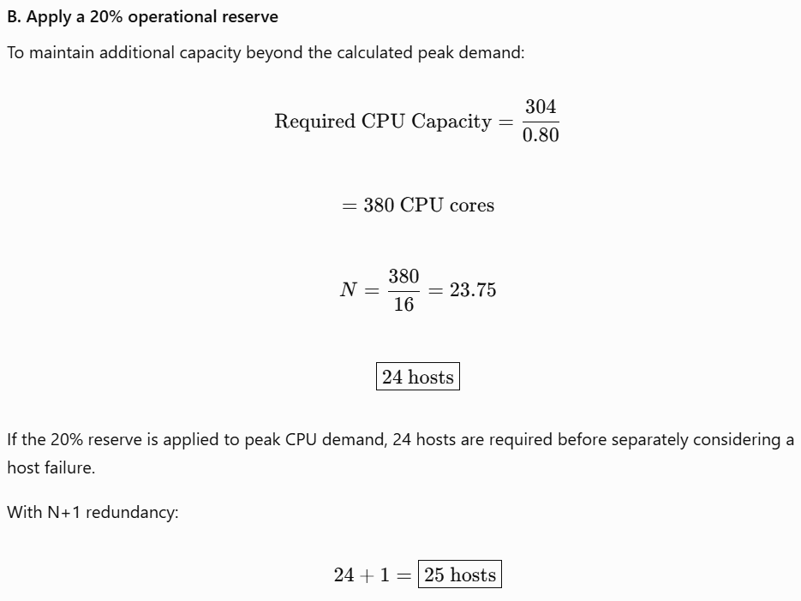

C. Final sizing comparison
Sizing condition | Hosts required
Average CPU demand at 65% target | 7
Average memory demand | 15
Peak CPU demand at 95% | 19
Peak CPU with N+1 redundancy | 20
Peak CPU with 20% reserve | 24
Peak CPU with reserve and N+1 | 25
Recommended conservative capacity: 25 hosts, based on the assumption that the existing peak CPU demand must be supported with a 20% operational reserve and N+1 protection.
This is a theoretical capacity result, not an optimized purchasing plan. A practical design should also measure the actual application workload, CPU scheduling overhead, and memory utilization.
3.7 Resource Overcommitment and Management
Concept | Explanation
CPU Overcommitment | Allocating more virtual CPU cores than the number of physical CPU cores. It improves utilization when workloads do not use CPU simultaneously.
CPU Scheduling | The hypervisor distributes physical CPU execution time among virtual machines.
Memory Ballooning | A mechanism that reclaims unused memory from VMs and redistributes it to other VMs when required.
Noisy-Neighbour Problem | One VM consumes excessive shared resources, reducing the performance of other VMs.
Resource Management Strategy
- Avoid excessive CPU and memory overcommitment during examination periods.
- Use CPU reservations for critical applications such as the Examination Portal.
- Apply resource limits to prevent one VM from consuming all available resources.
- Monitor CPU ready time, memory pressure, disk latency, and network throughput.
- Use workload scheduling to distribute applications across available hosts.
- Reserve sufficient capacity for host failure and future workload growth.
3.8 Proposed Server Consolidation Plan
The university should use a centralized virtualization cluster with shared storage and automated workload scheduling.
Application | Proposed Deployment
Student Information System | VM cluster
Learning Management System | VM or container cluster
Library Management System | VM
Examination Portal | Dedicated high-priority VMs
Research Applications | VMs with controlled resource allocation
Institutional Website | Containers or VMs
The proposed architecture allows applications to share physical resources while remaining logically isolated.
3.9 Conclusion
Server consolidation can significantly improve the university's infrastructure utilization and reduce the need for dedicated physical servers.
The calculations show that seven hosts are sufficient for average CPU demand at 65% utilization, while memory requires 15 hosts under the stated memory assumption.
However, peak CPU demand and N+1 redundancy increase the required capacity. A conservative design with a 20% operational reserve and one-host failure protection requires 25 hosts under the assumptions used.

TASK 4 – Compare Virtual Machines and Containers
CSA15 – Cloud Computing and Big Data Analytics | CO1 Assignment 1
Maximum Marks: 4
4.1 Introduction
Virtual machines (VMs) and containers are two important technologies used in a virtualized cloud data centre.
A virtual machine provides a complete virtual hardware environment with its own operating system. A container provides an isolated application environment while sharing the operating system kernel of the host.
The university can use both technologies to deploy applications efficiently, improve scalability, and reduce infrastructure costs.
4.2 Architecture of Virtual Machines
A virtual machine is created using a hypervisor that allocates physical hardware resources to multiple virtual machines.
Each VM contains:
- Virtual CPU
- Virtual memory
- Virtual storage
- Guest operating system
- Application software

4.3 Architecture of Containers
Containers package an application with its libraries, dependencies, and configuration files.
They share the host operating system kernel but maintain isolated application environments.
4.4 Comparison Between Virtual Machines and Containers
Feature | Virtual Machines | Containers
Architecture | Virtual hardware and guest OS | Shared host OS kernel
Isolation | Strong isolation through hypervisor | Process-level isolation
Operating System | Each VM has its own guest OS | Share host OS kernel
Startup Time | Generally slower | Generally faster
Resource Overhead | Higher due to guest OS | Lower due to shared kernel
Portability | VM images can be moved between compatible hypervisors | Container images can be deployed on compatible container runtimes
Management | Managed using hypervisor platforms | Managed using Docker and Kubernetes
Security | Suitable for strong workload separation | Requires careful kernel and container security configuration
Best Use | Legacy systems and databases | Web applications and microservices
4.5 Mapping University Workloads to VMs and Containers
University Workload | Recommended Technology | Justification
Student Information System | VM | Supports legacy applications and independent operating-system environments.
Learning Management System | Containers | Supports rapid deployment, scaling, and frequent updates.
Library Management System | VM | Provides an independent environment for the application and database.
Examination Portal | Containers | Enables horizontal scaling during examination periods.
Research Applications | VMs | Supports applications requiring different operating systems and dependencies.
Institutional Website | Containers | Allows lightweight deployment and easy scaling.
Database Server | VM | Provides dedicated resource allocation and strong workload separation.
Justification
The university should adopt a hybrid VM-container strategy.
Critical and legacy applications should run inside VMs, while scalable web services and microservices should run inside containers.
This approach provides flexibility, resource efficiency, and appropriate isolation for different workloads.
4.6 Role of Docker and Kubernetes
Docker
Docker is a containerization platform that packages applications and their dependencies into container images.
Its major advantages are:
- Consistent application deployment.
- Lightweight execution.
- Faster startup.
- Easy application packaging.
- Simplified development and testing.
Kubernetes
Kubernetes is a container orchestration platform used to manage containerized applications across multiple servers.
Its functions include:
- Container deployment and scheduling.
- Automatic scaling based on workload demand.
- Restarting failed containers.
- Load balancing.
- Rolling updates.
- Managing application replicas across nodes.
For example, during university result publication, Kubernetes can increase the number of Examination Portal containers to handle additional student requests.
4.7 Situations Where VMs Are More Appropriate
VMs are preferred when:
- Applications require different operating systems.
- Legacy applications depend on specific OS configurations.
- Strong isolation is required between critical workloads.
- Applications require a complete virtual hardware environment.
- The workload is a traditional database or enterprise application.
Containers are more appropriate for lightweight applications, microservices, and workloads requiring rapid scaling.
4.8 Conclusion
Virtual machines and containers provide different advantages in a cloud data centre.
VMs provide complete operating-system isolation and are suitable for legacy and critical applications. Containers provide lightweight execution, rapid deployment, and efficient scaling.

TASK 5 – Design Virtualized Storage and Network Infrastructure
CSA15 – Cloud Computing and Big Data Analytics | CO1 Assignment 1
Maximum Marks: 4 | Suggested length: 2 pages
5.1 Introduction
Virtualized storage and network infrastructure allow multiple virtual machines and applications to share physical storage and networking resources efficiently.
For the university data centre, storage virtualization provides centralized data management, while network virtualization provides secure communication between applications, students, faculty, and administrators.
The proposed infrastructure uses Software-Defined Storage (SDS), virtual switches, VLANs, and Software-Defined Networking (SDN) to improve performance, security, scalability, and availability.
5.2 Storage Virtualization
Storage virtualization is the process of combining multiple physical storage devices into a single logical storage pool.
It allows administrators to allocate storage to virtual machines without directly managing individual physical disks.
For example, the university can combine storage from multiple servers into a shared storage pool and allocate virtual disks to the Student Information System, Examination Portal, and Learning Management System.
Types of Storage
Storage Type | Description | Advantages | Limitations
DAS | Storage directly attached to a server. | Simple and low cost. | Limited sharing and scalability.
NAS | File-level storage accessed through a network. | Easy file sharing and centralized management. | Network bandwidth may affect performance.
SAN | Block-level storage accessed through a dedicated storage network. | High performance and suitable for enterprise databases. | Higher cost and complexity.
Recommended Storage Approach
The university should use a combination of NAS and SAN or equivalent shared block storage, depending on application requirements.
- SAN or shared block storage for databases and examination systems.
- NAS for research documents, shared files, and backups.
- Local SSD storage for temporary or high-performance workloads.
5.3 Software-Defined Storage (SDS)
Software-Defined Storage separates storage management software from the underlying physical storage hardware.
It allows storage resources to be pooled, provisioned, monitored, and managed centrally.

Important SDS Technologies
Technology | Explanation
Thin Provisioning | Allocates logical storage capacity without immediately consuming all physical storage.
Snapshots | Creates point-in-time copies of data for recovery or testing.
Replication | Copies data to another storage system or location for availability and disaster recovery.
Backup | Maintains independent copies of data to recover from accidental deletion, corruption, or failure.
For example, the university can create a snapshot of the Examination Portal database before applying a software update.
However, snapshots alone are not a replacement for independent backups.
5.4 Network Virtualization
Network virtualization creates logical networks using software instead of relying only on physical network connections.
It allows multiple virtual machines to communicate through virtual networks while remaining separated from other workloads.
Important Network Components
- Virtual Switch: Connects virtual machines and virtual network interfaces.
- VLAN: Separates network traffic into logical broadcast domains.
- Virtual Network: Provides software-defined connectivity between workloads.
- SDN: Separates the network control plane from the forwarding plane to enable centralized network management.
Proposed Network Segmentation
Network Segment | Purpose
Administration VLAN | Connects administrative applications and staff systems.
Student Services VLAN | Supports SIS, LMS, and student-facing applications.
Database VLAN | Provides restricted communication between application servers and databases.
Management VLAN | Supports hypervisor management, monitoring, and administration.
Backup VLAN | Transfers backup and replication traffic separately.

5.5 Proposed Storage and Network Design
The proposed design connects physical hosts to shared storage using a redundant storage network. Virtual machines communicate through virtual switches, while VLANs separate student services, databases, administration, and management traffic.

Design Justification
Requirement | Proposed Technology | Justification
Performance | SSD and shared block storage | Supports database and examination workloads.
Security | VLANs and network access control | Restricts unauthorized communication.
Availability | Redundant storage and network paths | Reduces single points of failure.
Scalability | SDS and virtual networks | Allows resources to be expanded without major redesign.
Cost | Storage pooling and thin provisioning | Reduces unnecessary storage purchases.
5.6 Conclusion
Virtualized storage and network infrastructure improve resource utilization, centralized management, and application availability.
The university should implement SDS, shared storage, virtual switches, VLAN-based segmentation, and SDN-based management. These technologies provide a scalable and secure foundation for the virtualized university data centre.

TASK 6 – Plan Resource Allocation, Scheduling and Monitoring
6.1 Introduction
Resource allocation is the process of assigning CPU, memory, storage, and network resources to virtual machines and containers according to application requirements.
The university data centre experiences varying workloads during normal academic activities, admissions, examinations, and result publication. Therefore, dynamic resource allocation and centralized monitoring are required to maintain performance and reduce resource wastage.
The proposed infrastructure uses resource reservations, limits, shares, load balancing, workload scheduling, and automated monitoring.
6.2 Resource Allocation Methods
Resource | Allocation Method | University Application
CPU | Assign virtual CPU cores and scheduling priorities. | Examination Portal receives higher priority during exams.
Memory | Allocate RAM with reservations and limits. | Database VMs receive sufficient reserved memory.
Storage | Allocate virtual disks from shared storage pools. | SIS database receives high-performance storage.
Network | Allocate bandwidth and apply traffic policies. | Student services receive sufficient bandwidth during peak periods.
6.3 Static and Dynamic Resource Allocation
Feature | Static Allocation | Dynamic Allocation
Allocation | Resources are assigned in advance. | Resources change according to workload demand.
Flexibility | Limited | High
Resource utilization | May cause wastage. | Improves utilization.
Performance | Predictable for fixed workloads. | Adapts to changing demand.
Example | Examination VM always receives 8 vCPUs. | LMS scales resources during admission.
Resource Reservations, Limits and Shares
- Reservation: Minimum resources guaranteed to a VM.
- Limit: Maximum resources a VM can consume.
- Shares: Relative priority when multiple VMs compete for resources.
For example, the Examination Portal can receive a CPU reservation to ensure sufficient processing capacity during examinations.
6.4 Load Balancing, Scheduling and Auto-Scaling
Load balancing: Distributes incoming requests across multiple servers or application instances.
Workload scheduling: Selects a suitable physical host or container node based on resource availability and workload requirements.
Auto-scaling: Automatically increases or decreases the number of application instances according to demand.
High availability: Automatically restarts or relocates workloads when a host or application fails.
For example, during result publication, the university can increase the number of LMS or examination web-service instances to handle increased student traffic.
6.5 Monitoring Indicators and Thresholds
Performance Indicator | Warning Threshold | Corrective Action
CPU Utilization | Above 75% for 10 minutes | Investigate CPU demand and redistribute workloads.
Memory Utilization | Above 80% | Check memory pressure and increase available RAM.
Disk I/O Latency | Above 20 ms | Investigate storage contention and optimize disk placement.
Network Throughput | Above 80% of link capacity | Increase bandwidth or redistribute traffic.
Application Latency | Above 500 ms | Check application performance and load balancing.
VM Availability | Below 99.9% | Investigate failures and improve failover.
These thresholds are proposed monitoring policies, not measured results from the university.
6.6 Monitoring and Alerting Plan
The university should implement centralized monitoring using tools such as Prometheus, Grafana, and hypervisor management software.
The monitoring system should:
- Collect CPU, memory, disk, and network metrics.
- Display infrastructure performance through dashboards.
- Generate alerts when thresholds are exceeded.
- Record system events and resource contention.
- Notify administrators through email or monitoring alerts.
- Support capacity planning using historical performance data.
Resource Contention Response
When resource contention occurs, the administrator should:
- Identify the VM or application consuming excessive resources.
- Check CPU scheduling delays and memory pressure.
- Increase resource reservations for critical applications.
- Migrate workloads to less-utilized hosts when appropriate.
- Scale application instances during peak demand.
- Review capacity requirements before future admission and examination periods.
6.7 Conclusion
The university should adopt dynamic resource allocation, workload scheduling, load balancing, auto-scaling, and centralized monitoring.
These mechanisms improve resource utilization, reduce performance bottlenecks, and ensure that critical university applications receive sufficient resources during peak workloads.

TASK 7 – Availability, Security and Disaster Recovery
7.1 Introduction
The university data centre hosts important services such as the Student Information System (SIS), Learning Management System (LMS), Library Management System, Examination Portal, and research applications. Failure or unauthorized access to these services can interrupt academic activities and expose confidential information.
Therefore, the proposed virtualized data centre must provide high availability, security controls, backup, and disaster recovery.
7.2 Availability and Fault Tolerance
High availability (HA) keeps services running or restores them quickly when a component fails.
Fault tolerance allows a system to continue operating despite a hardware or software failure.
The university can improve availability through:
- Multiple virtualization hosts.
- High-availability clustering.
- Live migration of running VMs during planned maintenance.
- Redundant network switches and links.
- Redundant power supplies and UPS.
- Load balancing across application instances.
- Regular health monitoring and failure alerts.
If one physical host fails, the HA system can restart its VMs on another available host, provided sufficient spare capacity is available.
7.3 Security Risks and Controls
Security Risk | Possible Impact | Recommended Control
Unauthorized access | Exposure of student and staff information | Multi-factor authentication (MFA) and role-based access control (RBAC)
VM escape or hypervisor vulnerability | Compromise of other VMs or the host | Patch hypervisors and restrict administrative access
Network attacks | Service disruption or data theft | VLAN segmentation, firewalls, and network monitoring
Data loss | Loss of academic records | Regular backups and replication
Malware or ransomware | Applications and data become unavailable | Endpoint protection, backup isolation, and security updates
Misconfiguration | Accidental exposure of services | Secure configuration standards and periodic audits
Security Measures
- Apply the principle of least privilege.
- Use separate administrator accounts.
- Protect management interfaces through a dedicated management network.
- Encrypt sensitive data during transmission and storage.
- Update hypervisors, operating systems, and applications regularly.
7.4 Backup and Disaster Recovery
Backup creates copies of data that can be restored after accidental deletion, corruption, or cyberattack.
Disaster recovery (DR) restores IT services after a major failure, such as a data-centre outage, fire, or severe hardware failure.
The university should maintain backups at a separate location and regularly test recovery procedures.
Backup Strategy
Backup Type | Purpose
Full Backup | Copies all selected data.
Incremental Backup | Copies changes since the last backup.
Off-site Backup | Protects data if the primary data centre is unavailable.
Immutable or Offline Backup | Helps protect backup copies from ransomware and unauthorized modification.
Replication | Maintains a copy of data or services at a secondary site.
7.5 RTO and RPO
- Recovery Time Objective (RTO): Maximum acceptable time to restore a service after failure.
- Recovery Point Objective (RPO): Maximum acceptable amount of data loss, measured in time.
The following are proposed targets for planning; they are not existing university commitments.
Application | Proposed RTO | Proposed RPO
Examination Portal | 1 hour | 15 minutes
Student Information System | 2 hours | 30 minutes
Learning Management System | 4 hours | 1 hour
Library Management System | 8 hours | 4 hours
Research Applications | 8 hours | 4 hours
Critical services such as the Examination Portal require shorter recovery times because downtime during examinations can affect students and faculty.
7.6 Disaster Recovery Procedure
- Detect the failure and notify the IT administrator.
- Identify the affected infrastructure and applications.
- Activate the disaster recovery plan if the primary site cannot be restored promptly.
- Restore data or services from the secondary site or backups.
- Verify application functionality and data integrity.
- Inform students, staff, and faculty when services are restored.
- Document the incident and update the recovery plan.
7.7 Conclusion
High availability, strong security controls, regular backups, and a tested disaster recovery plan are essential for the university data centre. These measures reduce downtime, protect confidential academic information, and support the continuity of university operations.

TASK 8 – Proposed Virtualized Data Centre Architecture
8.1 Introduction
The university’s existing data centre contains 20 physical servers with underutilized resources and limited centralized management. The proposed solution uses server virtualization, shared storage, virtual networking, centralized monitoring, and backup facilities.
The architecture consolidates university applications into virtual machines and containers while maintaining security, scalability, and availability.
8.2 Architecture Diagram
Insert the following labelled diagram into the Word document as the required Task 8 output.
8.3 Explanation of Architecture Layers
Layer | Components | Function
User Layer | Students, faculty, administration, public users | Access university applications through web or mobile interfaces.
Application Layer | SIS, LMS, Library, Examination Portal, research apps, website | Provides university services using VMs or containers.
Virtualization Layer | KVM or VMware hypervisor | Creates and manages virtual machines and allocates physical resources.
Storage Layer | SAN, NAS, off-site backups | Provides shared storage, file storage, and backup facilities.
Network Layer | Virtual switches, VLANs, firewalls, SDN | Connects workloads and separates traffic securely.
Resilience Layer | Security, HA clustering, replication, DR site | Protects services and data from failures and unauthorized access.
8.4 Deployment and Service Models
Deployment Model: Private Cloud
A private cloud is recommended because the university manages sensitive student records, examination data, staff details, and research information.
The private cloud provides:
- Greater control over infrastructure and data.
- Dedicated resources for university applications.
- Centralized administration and monitoring.
- Secure separation of university services.
A hybrid-cloud extension may be used later for non-sensitive workloads or additional capacity, subject to university security policies.

Service Models
Service Model | University Usage
Infrastructure as a Service (IaaS) | Virtual machines, virtual networks, and storage are provided to university IT administrators.
Platform as a Service (PaaS) | Application development and deployment platforms are provided to developers.
Software as a Service (SaaS) | Ready-to-use applications such as email or collaboration software are accessed by users.
The proposed university data centre mainly uses IaaS for its virtualized infrastructure.
8.5 Scalability and Availability
The architecture supports scalability through:
- Adding CPU, memory, and storage to the infrastructure.
- Creating additional VMs or container instances.
- Using load balancing to distribute application requests.
- Scaling application services during admission and examination periods.
- Migrating VMs between hosts when required.
High availability is provided through redundant hosts, clustering, failover, and continuous monitoring. If one host fails, affected VMs can be restarted on another available host.
8.6 Security and Disaster Recovery
Security is maintained through role-based access control, multi-factor authentication, network segmentation, firewalls, encryption, and regular patching.
Disaster recovery is supported through:
- Regular backups.
- Off-site backup storage.
- Replication to a secondary location.
- Defined RTO and RPO targets.
- Periodic backup restoration and disaster recovery testing.
8.7 Conclusion
The proposed virtualized data centre architecture provides centralized management, improved resource utilization, scalability, and secure access to university applications. By combining virtualization, shared storage, virtual networking, high availability, and disaster recovery, the university can build a reliable and flexible infrastructure for current and future workloads.

TASK 9 – Hands-on Implementation of Virtualization and Containerization
9.1 Introduction
This task demonstrates the practical implementation of virtualization and containerization. A virtual machine provides an isolated operating system environment, while a container packages an application and its dependencies for lightweight deployment.
For the university data centre, virtualization can host applications such as SIS and Library Management, while containers can deploy scalable services such as the LMS and Examination Portal.
9.2 Tools and Technologies Used
Tool | Purpose
Oracle VirtualBox | Creates and manages virtual machines.
Ubuntu Linux | Operating system installed inside the VM.
Docker | Builds and runs application containers.
Nginx | Provides a sample web service.
9.3 Practical Implementation
The following practical demonstrates a sample web server using Docker. It can be used as a basic demonstration of container deployment.
Step 1: Install Docker Desktop
- Download Docker Desktop from the official website: Docker Desktop.
- Install it on Windows.
- Enable the required WSL 2 support if prompted.
- Start Docker Desktop and wait until it is running.
Step 2: Verify Docker Installation
Open PowerShell or the VS Code terminal and execute:
docker --version
docker run hello-world
The commands display the installed Docker version and verify that Docker can run a test container.
Step 3: Download the Nginx Image
docker pull nginx
This downloads the official Nginx image from Docker Hub.
Step 4: Create and Run a Container
docker run -d --name university-web -p 8080:80 nginx
Explanation:
- -d runs the container in the background.
- --name university-web assigns a container name.
- -p 8080:80 maps port 8080 on the host to port 80 inside the container.
- nginx specifies the image.
Step 5: Verify the Running Container
docker ps
Open the browser and enter:
http://localhost:8080
The default Nginx welcome page should appear if the container is running successfully.
Step 6: Stop the Container
docker stop university-web
To remove the stopped container:
docker rm university-web
9.4 Virtual Machine Implementation Using VirtualBox
Step 1: Install VirtualBox
Download and install Oracle VirtualBox.
Step 2: Create a Virtual Machine
- Open Oracle VirtualBox.
- Click New.
- Enter the name as University-Ubuntu-VM.
- Select Ubuntu ISO file if already downloaded.
- Select Linux as the operating system type and Ubuntu (64-bit) as the version.
- Allocate the following resources.
Step 3: Configure Virtual Machine Resources
Resource | Recommended Setting
RAM | 4 GB
Virtual CPU | 2 cores
Virtual Hard Disk | 25 GB
Network | NAT
Operating System | Ubuntu Linux
These are suggested settings for a demonstration VM, not production server specifications.
Step 4: Start the VM
- Click Start.
- Complete the Ubuntu installation.
- Log in to the Ubuntu desktop.
- Open the terminal and execute:
uname -a
free -h
df -h
These commands display operating system information, memory usage, and disk space.
Step 5: Verify VM Operation
Check that Ubuntu starts successfully and that the allocated CPU, memory, and disk resources are available.
9.5 Testing and Verification
Test Case | Expected Result | Verification
VM creation | Virtual machine is created successfully. | VirtualBox Manager
VM startup | Ubuntu starts successfully. | Ubuntu desktop
Resource allocation | Configured RAM and CPU are available. | VirtualBox settings and Ubuntu commands
Docker image download | Nginx image downloads successfully. | Terminal output
Container execution | Nginx container runs successfully. | docker ps
Web service access | Nginx welcome page appears. | Browser at localhost:8080
Container shutdown | Container stops successfully. | docker ps -a

9.6 Practical Output Screenshots
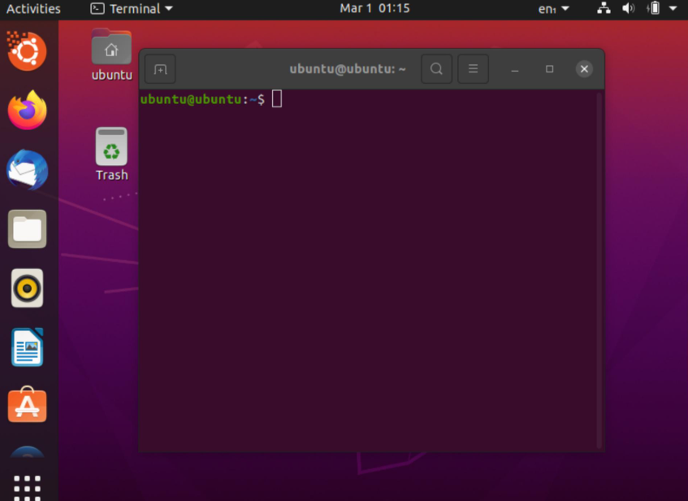

- Docker Installation
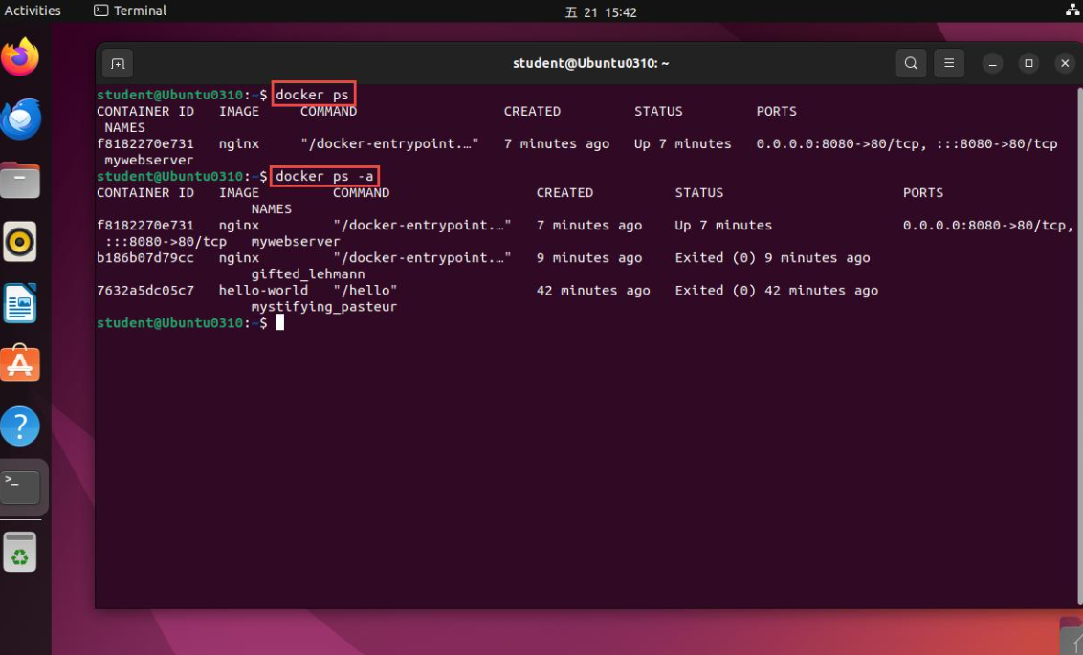

- Running Container and Monitoring
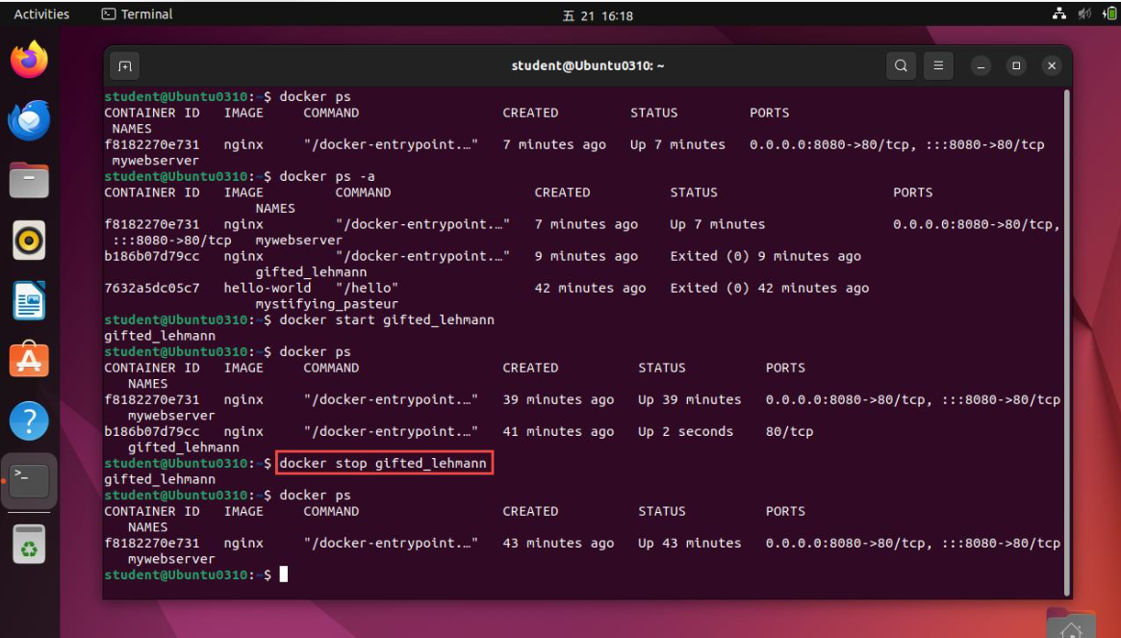
- Resource Configuration and Validation
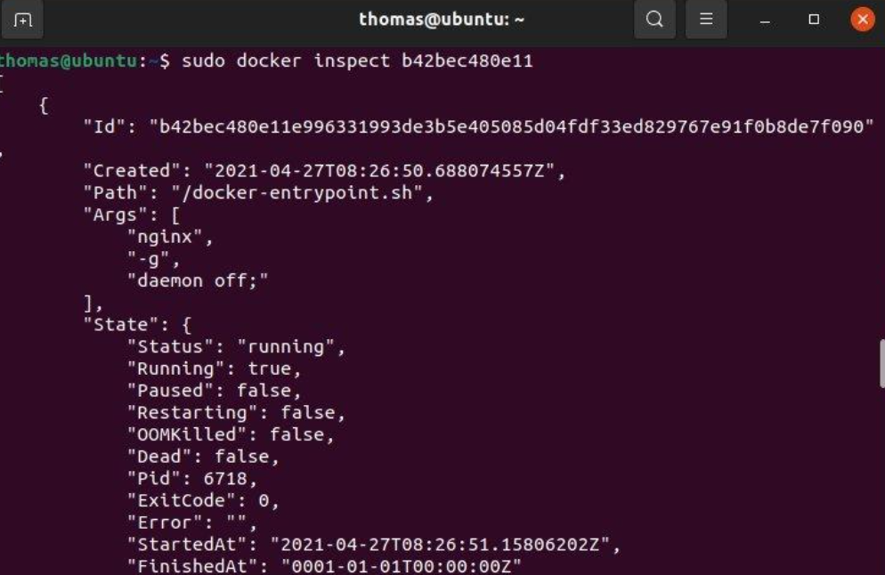
9.7 Result and Conclusion
The practical implementation demonstrates the creation of a virtual machine using Oracle VirtualBox and the deployment of an Nginx web server using Docker.
The virtual machine provides an isolated operating system environment, while Docker enables lightweight application deployment. Both technologies help the university data centre improve resource utilization, application isolation, and deployment flexibility.
TASK 10 – Cost Analysis and Implementation Roadmap
10.1 Introduction
Implementing a virtualized data centre requires an initial investment in hardware, software, networking, storage, and management tools. However, virtualization can reduce long-term operational expenses by improving hardware utilization and reducing the number of physical servers required.
This task compares the existing physical data centre with a proposed virtualized data centre and a cloud-based solution.
10.2 Cost Comparison
The following table provides an illustrative cost comparison in Indian Rupees (₹). These are planning estimates, not actual vendor quotations.
Cost Component | Existing Physical DC | Virtualized DC | Public Cloud
Initial Hardware | ₹40,00,000 | ₹30,00,000 | ₹0
Software and Licensing | ₹3,00,000 | ₹5,00,000 | Included / usage-based
Storage and Networking | ₹8,00,000 | ₹6,00,000 | Usage-based
Annual Maintenance | ₹5,00,000 | ₹3,00,000 | Included in service pricing
Annual Power and Cooling | ₹6,00,000 | ₹3,00,000 | Provider-managed
Annual Administration | ₹4,00,000 | ₹3,00,000 | ₹2,00,000
Initial Investment | ₹51,00,000 | ₹44,00,000 | ₹0
Estimated Annual Operating Cost | ₹15,00,000 | ₹9,00,000 | ₹12,00,000
Assumptions: The public-cloud estimate is a simplified annual planning allowance. Actual costs depend on VM sizes, storage, network transfer, backup, licensing, and usage. The initial-investment comparison excludes public-cloud migration costs.
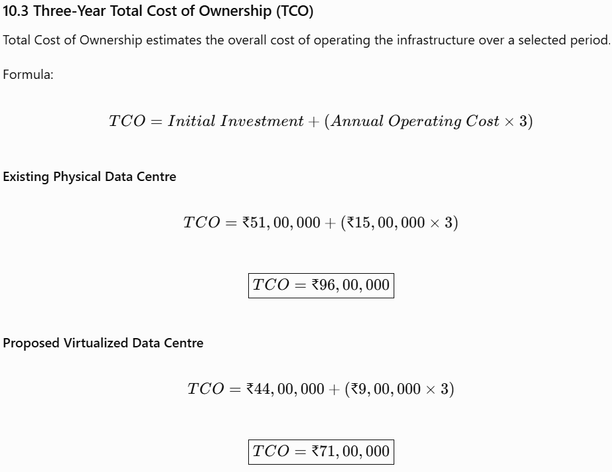
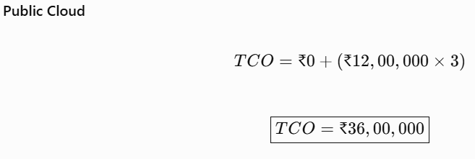
Three-Year Cost Comparison
Infrastructure | Three-Year TCO
Existing Physical DC | ₹96,00,000
Virtualized DC | ₹71,00,000
Public Cloud | ₹36,00,000

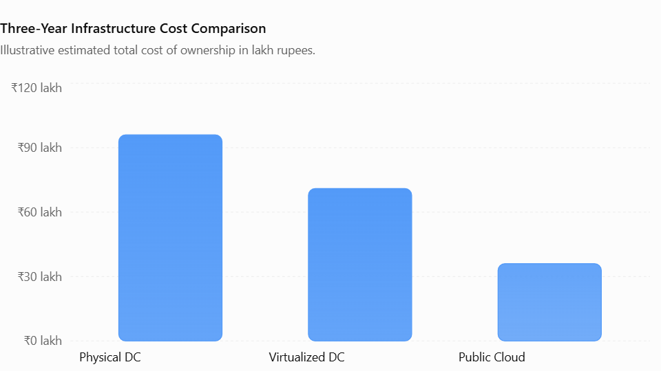
10.4 Benefits and Risks of Each Approach
Infrastructure | Benefits | Risks
Physical Data Centre | Complete hardware control and direct management. | High maintenance, power consumption, and hardware dependency.
Virtualized Data Centre | Better resource utilization, consolidation, and centralized management. | Initial migration cost and dependence on virtualization infrastructure.
Public Cloud | Flexible scaling, reduced hardware investment, and provider-managed infrastructure. | Ongoing usage charges, vendor dependency, and data governance concerns.
10.5 Recommended Approach
The recommended solution is a virtualized private cloud for the university.
Reasons:
- Protects sensitive student, examination, and research data.
- Improves physical server utilization.
- Supports centralized resource management.
- Provides flexibility to increase resources when required.
- Supports high availability and disaster recovery.
- Reduces long-term operational expenses compared with the existing physical infrastructure.
Selected public-cloud services can be considered for non-sensitive workloads or temporary additional capacity after evaluating security and cost.

10.6 Phased Implementation Roadmap
Phase | Activities | Expected Outcome
Phase 1: Assessment | Analyse existing servers, applications, storage, and network. | Infrastructure requirements identified.
Phase 2: Infrastructure Setup | Procure virtualization hosts, shared storage, and network equipment. | Virtualization environment prepared.
Phase 3: Pilot Migration | Migrate non-critical applications and test performance. | Migration issues identified and resolved.
Phase 4: Full Migration | Migrate SIS, LMS, Library, and Examination applications in planned stages. | University applications hosted on virtual infrastructure.
Phase 5: Security and DR | Configure access controls, backups, HA, and disaster recovery. | Improved protection and service continuity.
Phase 6: Monitoring | Configure centralized monitoring and optimize resource allocation. | Continuous performance management.
10.7 Conclusion
The cost analysis indicates that virtualization can reduce the university's estimated three-year infrastructure cost from ₹96 lakh to ₹71 lakh under the stated assumptions.
Although public cloud has a lower illustrative three-year cost, a virtualized private cloud is recommended because it provides greater direct control over sensitive university information and infrastructure.
A phased implementation approach will reduce migration risks and support a smooth transition from the existing physical data centre.

TASK 11 – Adaptation of the Data Centre for Increased Workload and Multi-College Access
11.1 Introduction
The university plans to expand its digital learning services to affiliated colleges. This change will increase the number of users accessing the Learning Management System (LMS), Examination Portal, Student Information System (SIS), and other academic applications.
The existing virtualized data centre must therefore be redesigned to support higher workloads, secure access for multiple colleges, scalability, and improved availability.
Scenario assumption: The assignment brief contains two different expansion figures: one section mentions 10 affiliated colleges with a 5-times workload increase, while another mentions 40 colleges with a 10-times increase. To avoid underestimating infrastructure requirements, this design uses the more demanding assumption of 40 colleges and 10-times peak workload. Confirm with your faculty which scenario should be used in the final submission.
11.2 Impact of Increased Workload
The increased workload creates the following challenges:
Challenge | Impact on Data Centre | Proposed Solution
Increased users | Higher CPU and memory demand | Add compute capacity and auto-scaling.
Increased application requests | Slower response times | Load balancing and multiple application instances.
Increased data storage | Higher storage requirements | Expand shared storage and use storage virtualization.
Network traffic growth | Network congestion | Increase bandwidth and use network segmentation.
More college accounts | Increased security complexity | Role-based access and multi-tenant isolation.
Increased service dependency | Higher impact of system failure | High availability and disaster recovery.
11.3 Recommended Service and Deployment Models
Deployment Model: Hybrid Cloud
A hybrid cloud approach can combine the university's private cloud with selected public-cloud resources.
- The private cloud hosts sensitive student records, examination databases, and administrative applications.
- Public-cloud resources can provide additional capacity for non-sensitive services and temporary peak workloads.
- Secure connections and access controls protect communication between environments.
Service Models
Service Model | Application
IaaS | Provides scalable virtual machines, storage, and networking.
PaaS | Supports development and deployment of college-specific applications.
SaaS | Provides online learning, collaboration, and academic services.
11.4 Multi-Tenant Architecture
Multi-tenancy allows multiple colleges to use a shared application platform while keeping their data and access logically separated.
The university should implement:
- A unique college ID for every affiliated college.
- Separate user accounts and role-based permissions.
- College-specific data access restrictions.
- Separate logical database schemas or appropriately isolated databases.
- Network segmentation and access policies.
- Centralized monitoring by authorized university administrators.
For example, a student from College A must only access their own college's academic records and must not view the records of College B.
11.5 Handling 10-Times Peak Workload
The architecture should support increased traffic using the following methods:
- Deploy additional application containers during peak periods.
- Use load balancers to distribute incoming requests.
- Scale CPU and memory resources according to workload demand.
- Use database connection pooling and query optimization.
- Implement caching for frequently accessed information.
- Expand storage and network capacity.
- Monitor performance continuously and generate alerts.
A load-testing exercise should simulate the expected peak number of concurrent users before the system is moved into production.
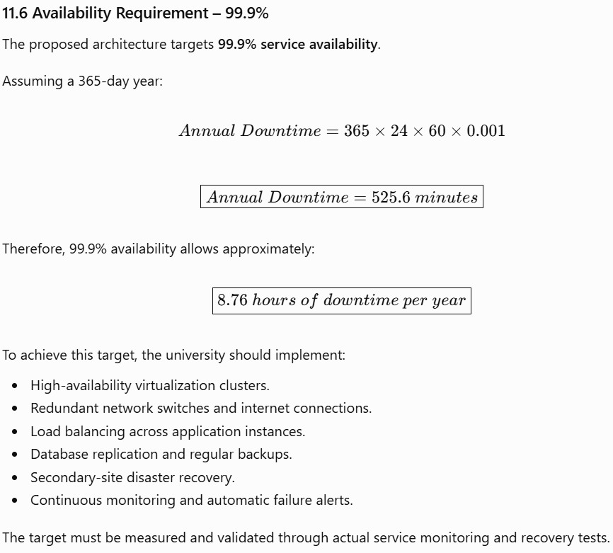
11.7 Final Recommendations
The university should implement the following improvements:
- Upgrade compute, storage, and network capacity.
- Introduce multi-tenant architecture for affiliated colleges.
- Use containers and auto-scaling for applications with variable workloads.
- Implement load balancing and high-availability clusters.
- Strengthen security through MFA, encryption, and access isolation.
- Maintain off-site backups and a secondary disaster recovery site.
- Conduct regular load testing and security assessments.
11.8 Conclusion
The redesigned architecture supports the university's expansion by providing scalability, secure multi-college access, and improved service availability. The combination of virtualization, containerization, hybrid cloud resources, and disaster recovery helps the university manage increased workloads while protecting academic information.

